ALLIANCE UNIVERSITY
Alliance College of Engineering and Design

Student-Centred and Industry-friendly
OBCFC Course Structure

PART B – Micro–Project Report

Course Code: E1CSA25202 Course Title: Programming in Python

Name of Course Incharge: Mr.Deepak Raj T

Library Management: Track books, handle issuing/returning, and maintain availability status

1.0 Rationale
Libraries manage a large collection of books and records, which becomes difficult when handled manually. Manual systems are time-consuming, error-prone, and inefficient, especially when tracking book availability, issuing, and returning books. Misplaced records and incorrect entries can lead to confusion and delays.

This project focuses on developing a Library Management System using Python to automate these tasks. The system allows adding books, issuing books, returning books, and displaying records efficiently. It ensures accuracy, reduces human effort, and provides quick access to information. This project demonstrates the application of programming concepts in solving real-world problems and improves system efficiency.

2.0 Competency of the Course
- Apply Python programming concepts to develop real-world applications
- Design menu-driven programs
- Implement data structures like lists and dictionaries
- Handle user input and validations

3.0 Course Outcomes Addressed
- CO2: Apply control structures in Python
- CO3: Develop Python programs using functions and data structures
- CO4: Solve real-world problems using programming

4.0 Literature Review

Library management has evolved from manual record-keeping to computerized systems. Traditional methods relied on registers, which were prone to errors and inefficiencies. Modern systems use software to automate operations such as book tracking, issuing, and returning.

Various studies show that automation improves accuracy and reduces workload. Programming languages like Python are widely used for such systems due to simplicity and flexibility. Basic systems use lists or databases to store records and provide user-friendly interfaces.

This project is based on a simple command-line system, which demonstrates fundamental concepts of software development without requiring complex tools or databases.

This project demonstrates the fundamental concepts of:
- Data storage using dictionaries
- Conditional statements
- Loops and user interaction
- Basic record management

5.0 Actual Methodology Followed
- Identified problems in manual library system
- Designed system with features:
- Add Book
- Issue Book
- Return Book
- Display Books
- Used Python dictionary to store book records
- Created menu-driven interface
- Implemented validation checks
- Tested system with different inputs

6.0 Actual Resources Used (Mention the actual resources used).

S. No. | Name of Resource/material | Specifications | Qty | Remarks
 | COMPUTER | WINDOWS | 1 | CODING
 | PYTHON | VERSION 3.x | 1 | PROGRAMMING
 | IDE | VS CODE | 1 | DEVELOPMENT

7.0 Outputs of the Micro–project

7.1 PROBLEM STATEMENT
Design and implement a Library Management System using a programming language that allows users to manage books efficiently.
The system should enable users to:
- Add new books with details like Book ID, Title, and Author
- Issue books to users
- Return issued books
- Display all available and issued books
- Exit the program
The system should maintain book records and track their availability status.

7.2 ALGORITHM
- Start
- Initialize empty dictionary library = {}
- Display menu (Add, Issue, Return, Display, Exit)
- Input user choice
- If choice == 1:
  - Input Book ID, Title, Author
  - Add book to library with available = True
  - Print "Book added successfully"
- Else if choice == 2:
  - Input Book ID
  - If Book ID exists:
    - If available → set available = False, print success
    - Else → print "Book already issued"
  - Else → print "Book not found"
- Else if choice == 3:
  - Input Book ID
  - If Book ID exists → set available = True, print success
  - Else → print "Book not found"
- Else if choice == 4:
  - If library is empty → print "No books available"
  - Else → display all book details with status
- Else if choice == 5:
  - Print "Exiting program"
  - Stop
- Else:
Print "Invalid choice"
- Repeat from step 3
- End

7.3 BLOCK DIAGRAM

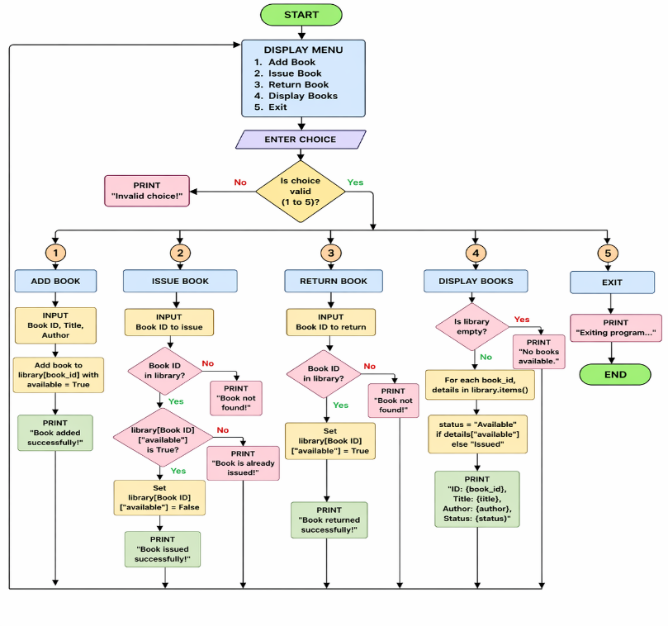

7.4 CODE USED

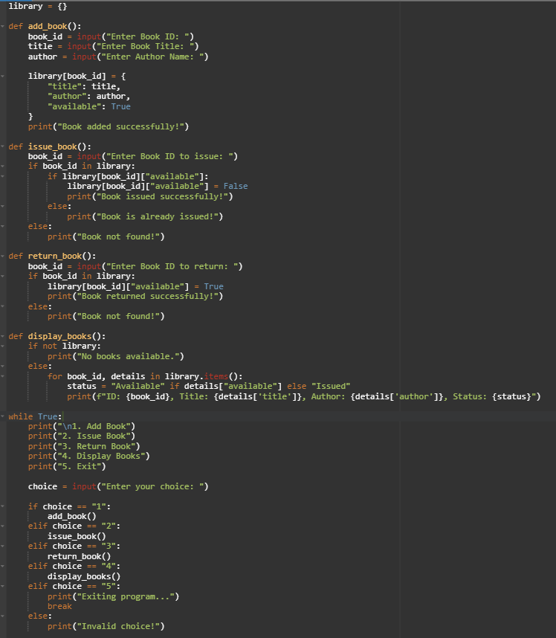

7.5 OUTPUT(TEST CASES)

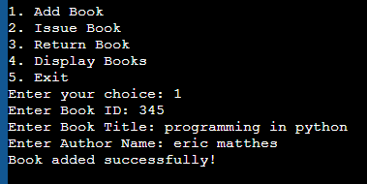 | 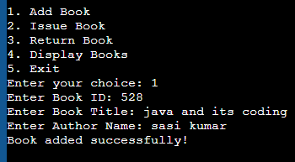
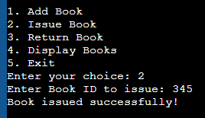 | 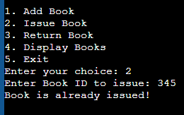
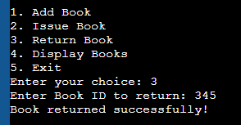

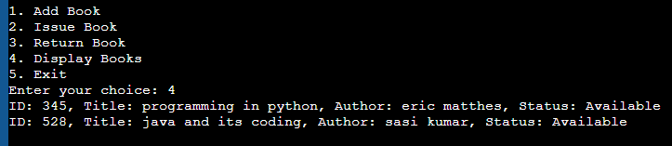

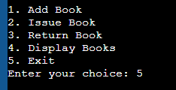

8.0 Benefits of this Micro–project

This micro-project helps in reducing manual errors and improves the efficiency of library operations. It saves time by automating tasks like adding, issuing, and returning books. The system ensures accurate tracking of book availability, which avoids confusion and duplication of records. It is user-friendly and easy to operate, even for beginners.

- Easy Book Management: Quickly add, issue, and return books
- Time Efficient: Reduces manual effort and saves time
- Error Reduction: Minimizes human mistakes compared to manual systems
- Real-Time Availability: Instantly shows whether a book is available or issued
- User-Friendly: Simple menu-driven interface
- Cost Effective: No need for physical registers or paperwork
- Scalable Base: Can be extended into a full system

9.0 Area of Future Improvement

The current Library Management System is a basic console-based application that performs essential operations like adding, issuing, returning, and displaying books. In the future, this system can be enhanced by integrating a database such as MySQL or SQLite to provide permanent data storage instead of temporary memory. A graphical user interface (GUI) can be developed using tools like Tkinter or web technologies to make the system more interactive and user-friendly. Additional features such as user authentication, search functionality, book reservation, and fine calculation for late returns can also be implemented. Furthermore, the system can be expanded to support multiple users and generate reports for better management and analysis. These improvements will make the system more efficient, scalable, and suitable for real-world applications.

- Add database (MySQL)
- GUI using Tkinter
- User login system
- Barcode integration
- Database Integration
- Replace dictionary with databases like MySQL for permanent storage
- User Authentication System
- Add login/signup for librarians and users
- Graphical User Interface (GUI)
- Use Tkinter or web interface for better user experience
- Search Functionality
- Search books by title, author, or ID
- Fine Calculation System
- Add late return penalties
- Multi-user Support
- Allow multiple users to access the system
- Book Reservation Feature
- Users can reserve unavailable books
- Report Generation
- Generate reports for issued/returned books

10.0 References

- Python Software Foundation. Python Documentation. Available at: https://docs.python.org/3/
- Reema Thareja. Python Programming Using Problem Solving Approach. Oxford University Press.
- Mark Lutz. Learning Python. O’Reilly Media.
- TutorialsPoint. Python Tutorial. Available at: https://www.tutorialspoint.com/python
- GeeksforGeeks. Python Programming Language. Available at: https://www.geeksforgeeks.org/python-programming-language/
- W3Schools. Python Tutorial. Available at: https://www.w3schools.com/python/

*********

